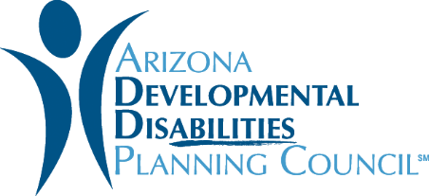
Request for Information

Sept. 30 – Oct. 24, 2019

Details: We’re opening up a one-month window to hear your fresh ideas that align with the Council’s mission and vision. You can do that by filling out this idea submission form.

As a grantmaking organization, we aim to fill gaps experienced by Arizonans with developmental disabilities. You are a partner in helping us raise the voice of people with disabilities. We need your help to do that.

We need you to share the needs and gaps you have observed in your communities. We also want new or innovative projects or ideas for what kind of support the Council should provide to address these gaps. You are also welcome to share what your community is currently doing to support people with developmental disabilities. The Council may use any of this information to guide our research, advocacy and future grant solicitations to support innovative ideas or projects.

Are you qualified? If you conduct business in Arizona, you and/or your organization is qualified to submit a Request for Information application. A person may submit multiple Request for Information applications.

Format for Submission: Submit this Microsoft Word application by emailing emcfadden@azdes.gov. The deadline for all submissions is October 24, 2019.

Things to Note
- We welcome your ideas and we consider each submission. However, the ADDPC doesn’t guarantee any financial agreement with an organization who submits ideas as part of the RFI process.
- If you have any questions, please email Erica McFadden at emcfadden@azdes.gov

ADDPC Request for Information Form

1. Full Name:

2. Email Address:

3. Phone number:

4. Tell us more about yourself and your organization (if applicable) and your experience with developmental disabilities:

5. What Council goal does your project idea address?

6. Please provide a description of your project idea - include as many details as possible.

7. What method would be used to offer this to the community?

8. How much would your idea potentially cost?

9. Which other organizations would be a partner on this idea?

10. What results do you expect after one year of the project?

11. Is there anyone else doing this now?

12. How could this project achieve sustainability in the future?

13. Why is this important for the Council to do?

