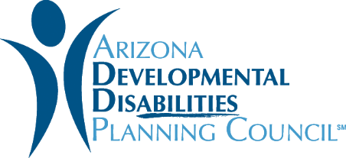
Goals & Objectives

Fiscal Year 2019

Goal 1: Self-Advocacy/Self-Determination
Establish, strengthen, and expand self-advocacy activities among people with developmental disabilities (DD) so they will become empowered to be self-determined.

Objective 1: The Council will increase and support opportunities for persons with intellectual or developmental disabilities (I/DD) who are community leaders, to provide leadership training and peer mentoring that will prepare and support their peers who wish to promote the positive perception and inclusion of persons with I/DD in their community.
Objective 2: The Council will support the participation of persons with I/DD in cross disability, culturally diverse leadership coalitions, groups, and civic and political life, which addresses issues of importance to persons with I/DD
Objective 3: The Council will establish and promote the success of one or more collaborative, culturally competent self-advocacy coalitions that are led by individuals who have I/DD and that includes representatives of unserved/underserved populations, by providing funding, technical assistance, and supports
Objective 4: The Council will expand opportunities for self-advocates to be their own guardians through limited guardianships and supported decision-making.

Goal 2: Employment
Increase awareness of employment potential of people who have developmental disabilities, link them to resources needed to achieve their employment potential, and foster job creation, hiring, retention, promotion, and self-employment.

Objective 1: In Collaboration with self-advocates, DD network partners, Employment First Core Team, professionals who provide support, and stakeholders, Arizona will become an Employment First State through the development, implementation and promotion of policies and practices that support integrated employment opportunities for people with disabilities.
Objective 2: Increase the array of quality life, job and technical skills trainings required for competitive employment, including self-employment for people with disabilities; promote education, credentialing and professional development for employment consultants and job developers.
Objective 3: Promote job creation, hiring, retention, entrepreneurship, and employment awareness best practices to improve employment outcomes for people with disabilities.

Goal 3: Inclusion
Motivate communities to include people of all ages who have developmental disabilities in all aspects of community life.

Objective 1: In coordination with DDD, the DD Network, and Raising Special Kids, lead the effort to build a Statewide Community of Practice (COP) that drives system change towards more inclusive culturally and linguistically competent processes and policies across Arizona (This is part of a 5-year project funded by Georgetown University).
Objective 2: Increase inclusion and build communities of support for people of all ages who have developmental disabilities and behavioral challenges or who are experiencing a crisis through outreach, education, and system change by working in collaboration with people with developmental disabilities, their families, schools, first responders, other stakeholders, and communities (including Tribal communities)
Objective 3: Identify and decrease barriers to community life for people who have developmental disabilities through their lifespan by targeting community members, families, and individuals with DD through outreach, education, linkage to community resources, and community engagement activities that promote inclusion.

*Note: A developmental disability is a severe, chronic disability that occurs before an individual is 22 that is likely to continue indefinitely and results in substantial functional limitations in three or more of the following areas: self-care, receptive and expressive language, learning, mobility, self-direction, capacity for independent living, and economic self-sufficiency. Diagnosed conditions may include autism, Down syndrome, intellectual disability, cerebral palsy, spina bifida, epilepsy, mental health issues, and others.

