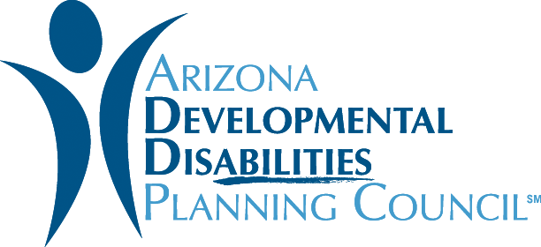

Doing Your Homework:
Questions Families and Individuals Can Ask Providers
- Review the latest inspection report for the group home or facility, often available online
- Ask what type of training employees receive on recognizing and reporting abuse, including sexual abuse. What type of qualifications are needed to work there?
- Ask how often staff members turn over
- Keep your eyes open; do the individuals seem happy and healthy? Are staff interacting with them positively?
- Find out how individuals are informed about how to recognize and report abuse. Is there a sign posted anywhere? Is any information given to families or individuals?
- Talk to other families and individuals about their experiences there.

Created January 2019
https://addpc.az.gov/

