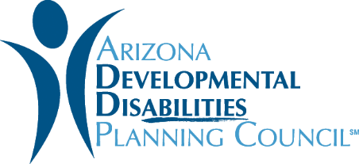
Request for Information

Application – 2018/2019

Pick a Category and Submit an Idea: The Council is looking for ideas that fall under at least one of the following categories –

- Self-advocacy/Self-determination – We want ideas on how to establish, strengthen, and expand self-advocacy activities among people with developmental disabilities so they will become empowered to be self-determined.

- Employment – We want to hear about ways to increase awareness of the employment potential of people with developmental disabilities, link them to resources needed to achieve their employment potential, and foster job creation, hiring, retention, promotion, and self-employment.

- Inclusion – We want to hear your ideas on how to motivate communities to include people of all ages who have developmental disabilities in all aspects of community life.

- Any project idea or best practice that supports our mission and vision.

Are you qualified? If you conduct business in Arizona, your organization is qualified to submit a Request for Information application. An organization may submit multiple Request for Information applications.

Format for Submission: Submit your application using our online Google Form or this Microsoft Word document by emailing Erica McFadden at emcfadden@azdes.gov. The deadline for all submissions is October 18, 2018, 4:30 PM Phoenix local time.

Things to Note
- We welcome your ideas and we consider each submission. However, the ADDPC doesn’t guarantee any financial agreement with an organization who submits ideas as part of the RFI process.
- If you have any questions, please email Erica McFadden at emcfadden@azdes.gov

Who is the Council? Please visit https://addpc.az.gov/ for more information about our work at Arizona Developmental Disabilities Planning Council.

What we’re doing and why it matters: We’re opening up a one-month window to hear your fresh ideas that align with the Council’s mission and vision. You can do that by filling out this Request for Information application.
As a grant-making organization, we aim to fill gaps experienced by Arizonans with developmental disabilities. You are a partner in helping us raise the voice of people with disabilities. You’re invited to be part of this important conversation so we can advance innovative solutions.

We need you to share the needs and gaps you have observed in your communities. We also want new or innovative projects or ideas for what kind of support the Council should provide to address these gaps. You are also welcome to share what your community is currently doing to support people with developmental disabilities.
The Council may use any submitted idea to guide our strategic plan and develop future grant solicitations to support innovative ideas or projects in the future.
Our Mission: We want to develop and support capacity building and systemic change to increase inclusion and involvement of people with developmental disabilities in their communities through the promotion of self-determination, independence and dignity in all aspects of life.

Our Vision: One community working together to achieve full inclusion and participation of people with developmental disabilities.

ADDPC Request for Information Form

- Full Name:
- Name of organization:
- Email Address:
- Phone Number:
- What Council goal does your project idea address? Check all that apply:
- Self-Advocacy/Self-Determination
- Community Inclusion
- Employment

- Provide a brief description of your project idea:
- How would you deliver this service?
- How much would your idea potentially cost?
- Which other organizations would be a partner on this project?
- What results do you expect after one year of the project?
- Is there anyone else doing this now?
- How could this project achieve sustainability in the future?
- Why is this important for the Council to do?

