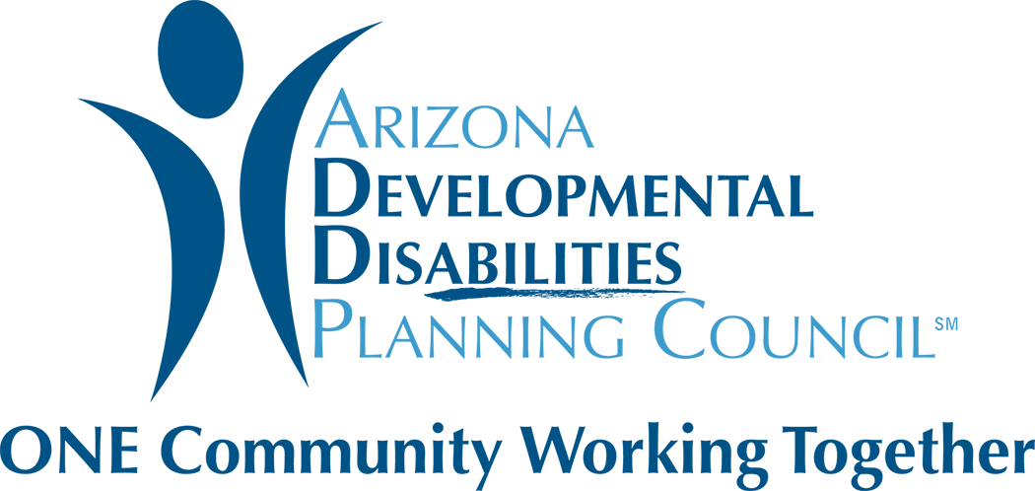

Sexual Abuse/Exploitation of Children & Adults
With Intellectual &/or Developmental Disabilities Roundtable
Tuesday, July 30, 2019 – 2:30 - 4:00 P.M.
3839 North 3rd Street, Suite 306, Phoenix, Arizona 85012
WebEx: 415-655-0003; access code 804 420 369

AGENDA ITEM

A. Welcome & Introductions

B. Purpose & Review of Roundtable

C. Overall Updates of Progress Made & Current Work Being Done

- RFGA Awarded on Sexual Abuse & Individuals with I/DD: Improvement Assurance Group
- Legislation Passed
- Executive Order
- Governor’s Task Force on Abuse & Neglect
- House Ad Hoc Committee on Abuse & Neglect of Vulnerable Adults

D. Participant Updates: Actions Taken to Address Sexual Violence & People with I/DD

E. Determining Next Steps

F. Next Meeting Date

G. Other Announcements

H. Adjourn

